Uploading pictures to F6 (Workaround):

- Upload your pictures to the \\galileo\pics drive as instructed.
- Copy your uploaded pictures from the Pics drive and save to your Pictures folder on your computer.

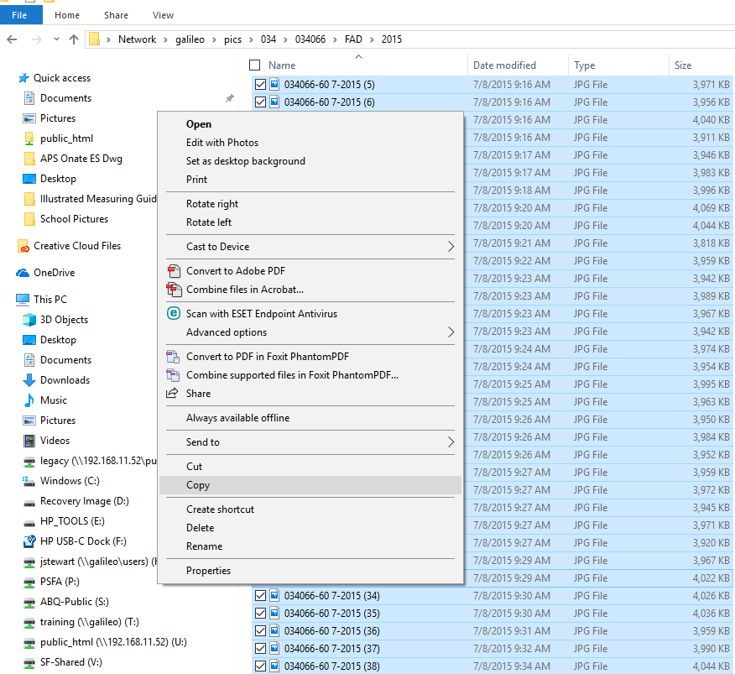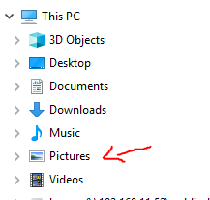

- Proceed to the F6 site and upload the pictures from your Pictures folder and NOT the \\Galileo\Pics folder.

If you have any questions, please call the IT dept. for help.

