How to share a file or folder in PSFAConnect
Locate file in your PSFAConnect box.
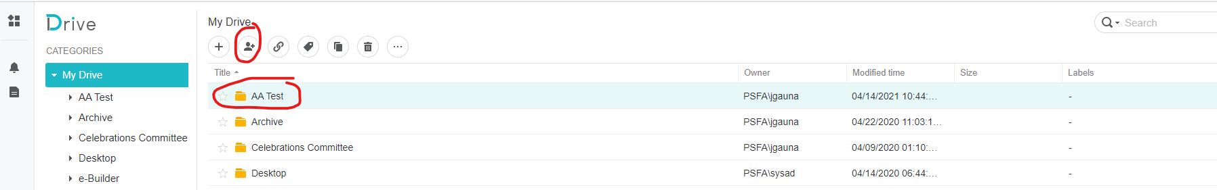
Click on the “Share” icon.
Change the “Privacy Settings” to “Public – Anyone with the link can view”
Click on the “Copy” icon. Then click “Save”
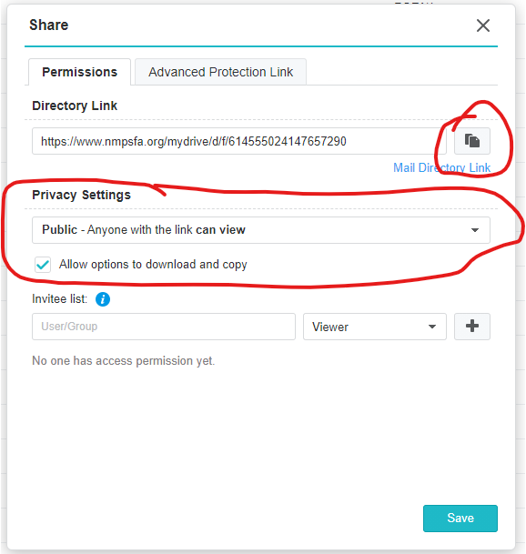
You will then see the “Shared” icon on to the right of the folder name.
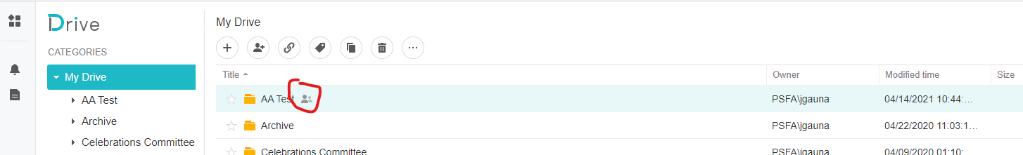
Open a new email to the person(s) you want to send the link and paste the link into the email. Once they click the link it will take them to the folder to view and/or download any file(s).

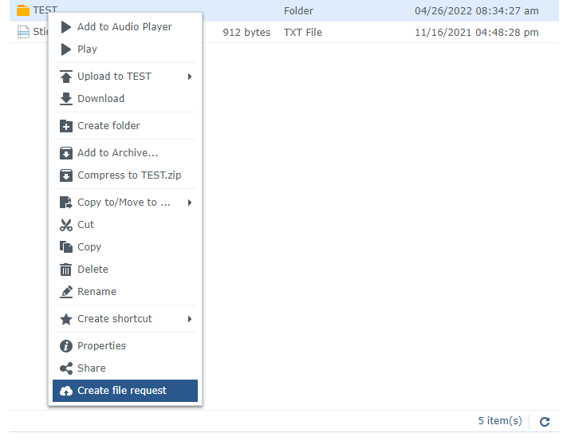
How to create a file request in ABQNAS01
Log into ABQNAS01 (https://nmpsfa.org:5001/)

Right click on the file that is the intended destination.
--Select Create file request.

In the Create file request window:
--Change the message to: “Please add your name below then click the add files button.”
--Add a password if the user requests. Make sure the user has the password to give to the external party.
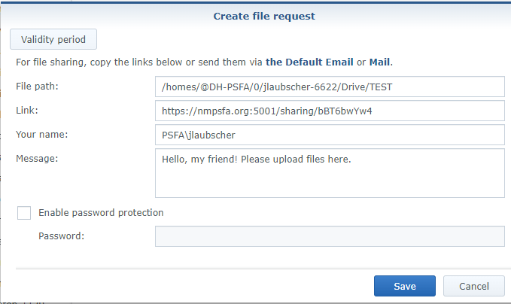
--Copy the link to send to the requesting user.
Click Save. And make sure the user gets the link and password if needed via email. Users can then send that to external users.

